User Guide for BIOS (Web UI)

G7T1

Contents

Logging In 2

Possible Errors When Logging In 2

1. Invalid Username and/or Password 2

2. Did not fill in all fields required when logging in 3

Admin Homepage 4

Bootstrap 5

Bootstrapping a File with No Errors 5

Bootstrapping a File with Errors 6

Additional Notes 6

Stop Round 7

Possible Errors when Ending Round 7

1. Round already ended 7

Start Round 8

Possible Errors 8

1. Round already started/has not ended 8

Student Homepage 9

Adding Bids 10

Problems When Adding Bids 11

1. Not All Form Fields are Filled 11

2. Unsuccessful Adding of Bids 12

Deleting Bids 13

Dropping Section 15

# Logging In

Upon entering the app, the user will be greeted by the following login page.

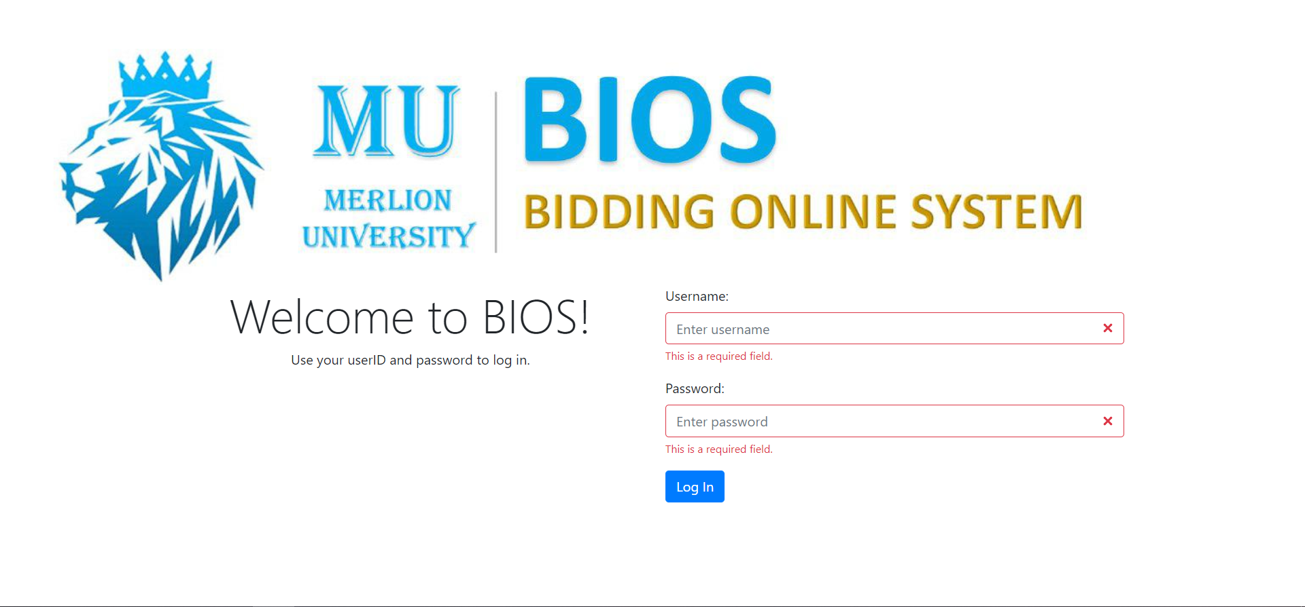

The user is required to key in their username and password into the corresponding form fields. Once this is done, the user has to click the log in button.

## Possible Errors When Logging In

### Invalid Username and/or Password

If the either the username or the password does not match or cannot be found in the database, the user will see the following message: “Invalid userID/password”. To fix this, ensure that the correct usename/password is keyed in.

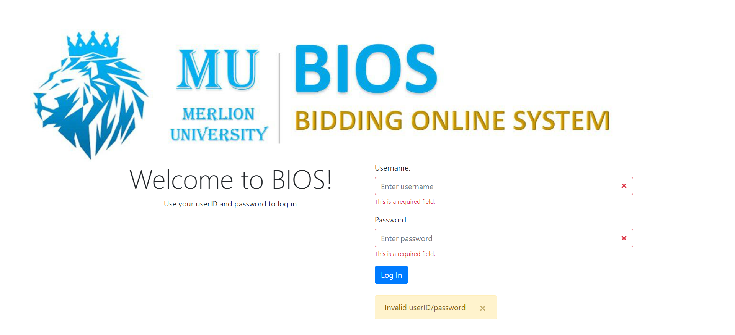

### Did not fill in all fields required when logging in

If either the username or password is not filled in, the system will prompt the user to fill in the fields that are left empty.

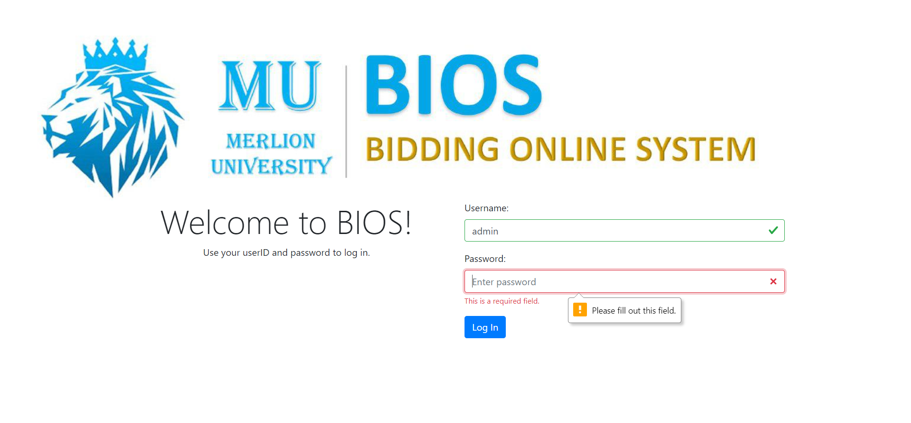



# Admin Homepage

Once the admin has successfully logged into the system, the admin will be redirected to the admin homepage as follows:

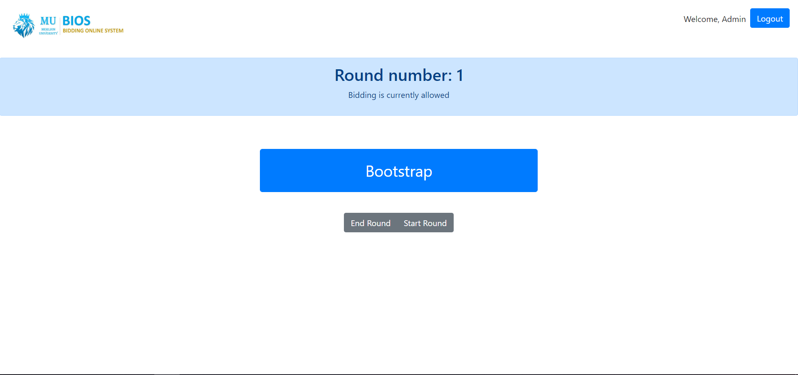

In this homepage, the admin can see the round number and whether the round is active (bidding allowed).

The admin homepage also includes the following buttons:

1. Bootstrap,
2. Start Round,
3. End Round,
4. And Logout.

# Bootstrap

When the admin clicks on the bootstrap button, it will lead to the following pop-up:

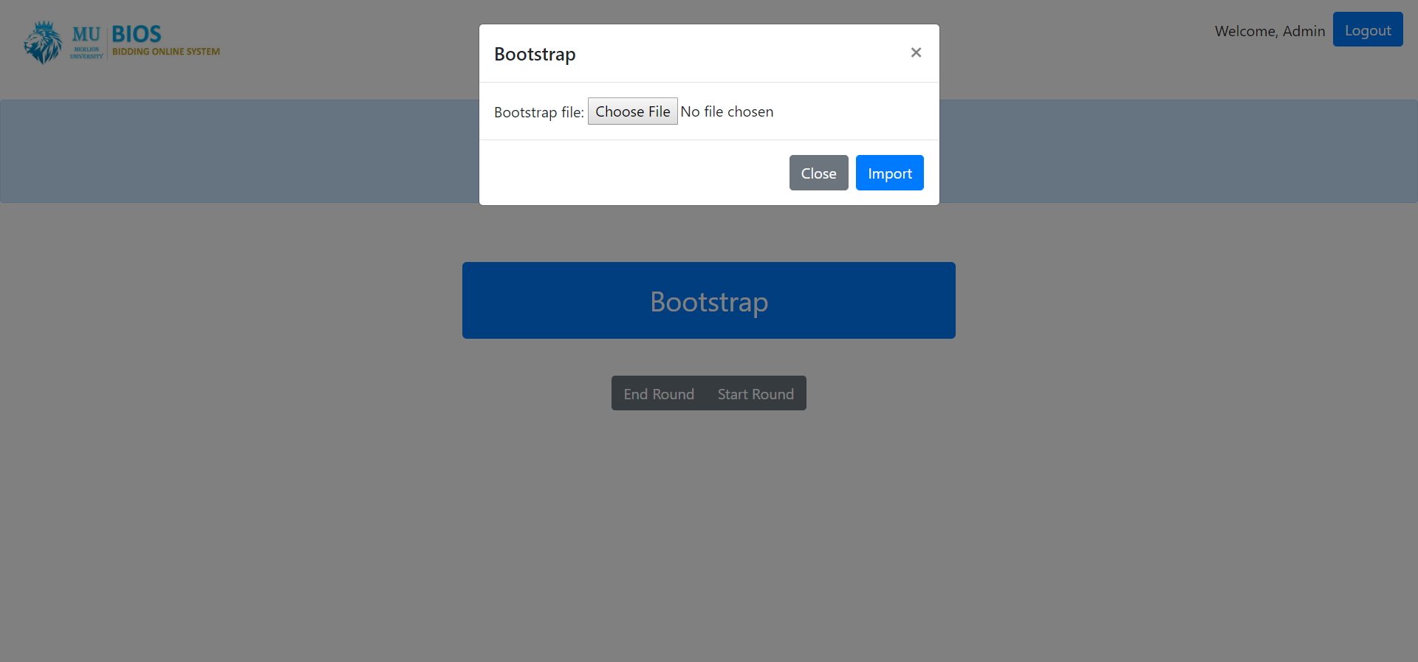

## Bootstrapping a File with No Errors

To import a file, click choose file, select the .zip file to bootstrap, and click import. If successful, the following message is shown: “Bootstrap Successful.”. In addition, the system will display the following table which shows how many records from each file has been processed by the system:

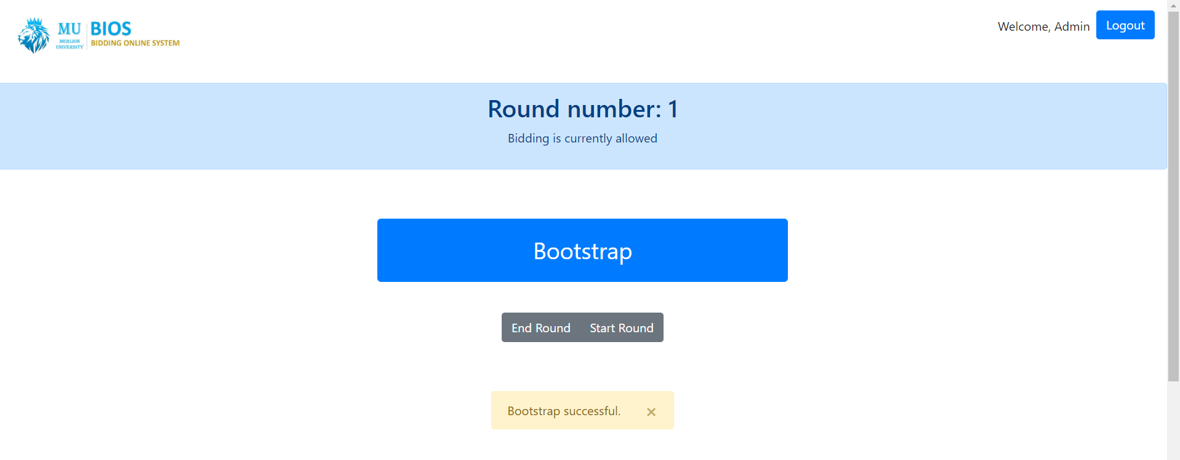

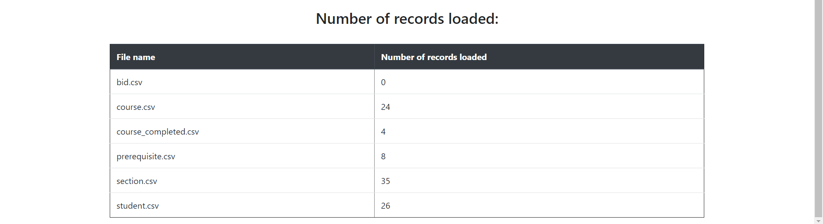

## Bootstrapping a File with Errors

However, if there are any errors in the bootstrap file, the system will display the following message: “Bootstrap has errors but bidding round will still start. See error messages below.“

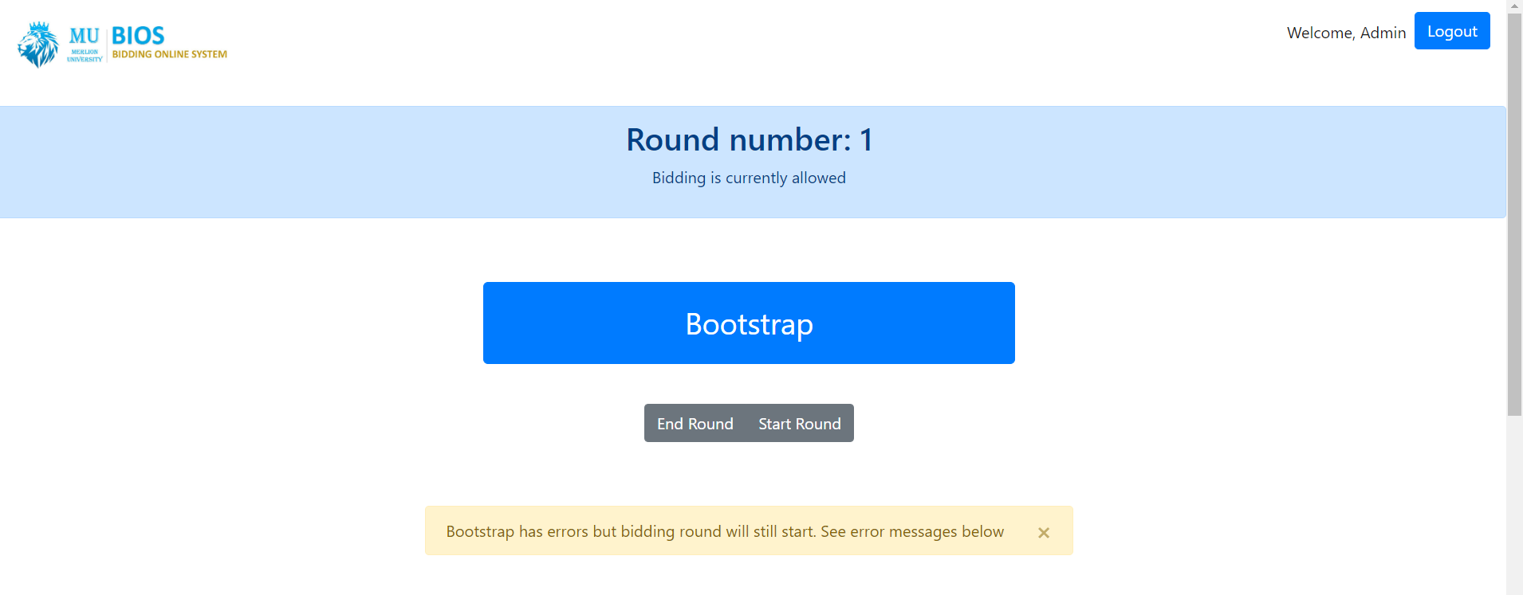

However, the admin can still see the number of records processed by the system for each file, as well as a table indicating the file, line number and why there was an error processing that particular record:

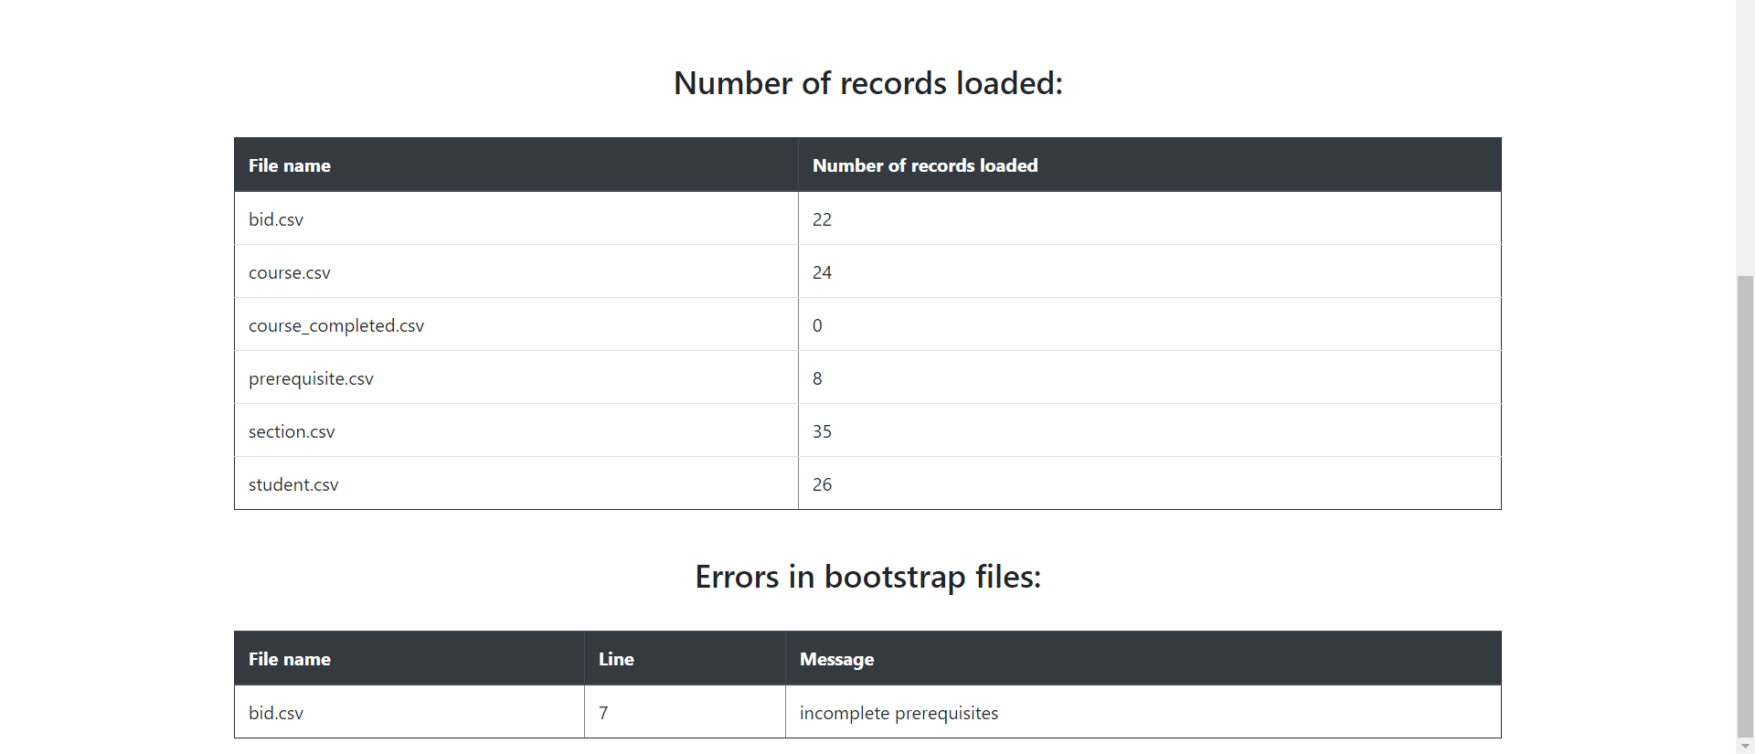

## Additional Notes

Regardless of whether the bootstrap files have errors or not, **Round 1 will still start**.

# Stop Round

To stop the current round, the admin has to click the “End Round” button found at the admin homepage. If the round is successfully ended, the following message is displayed: “Round Ended”.

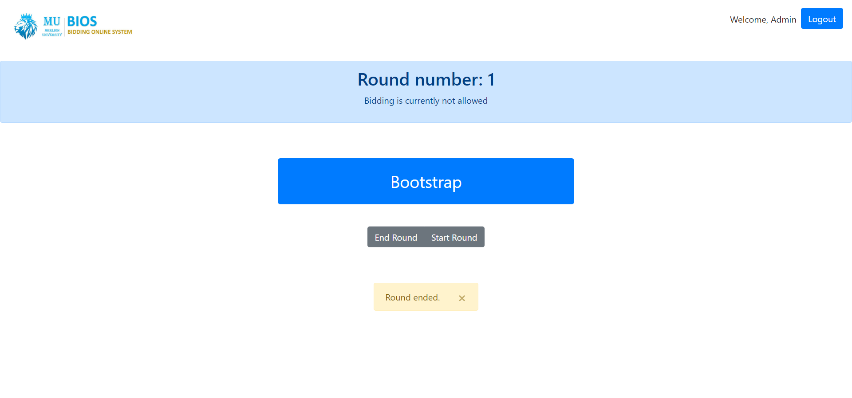

Since the round has ended, the line below the round number will change to “Bidding is currently not allowed”, which confirms that the round has ended. The appropriate processing logic will be applied for the round number which was ended.

## Possible Errors when Ending Round

### Round already ended

If the round has already ended, the following error message is displayed: “Either invalid round or round has already ended”. This could be due to the following:

1. Did not bootstrap after importing SQL files.
2. Ended a round without starting it.

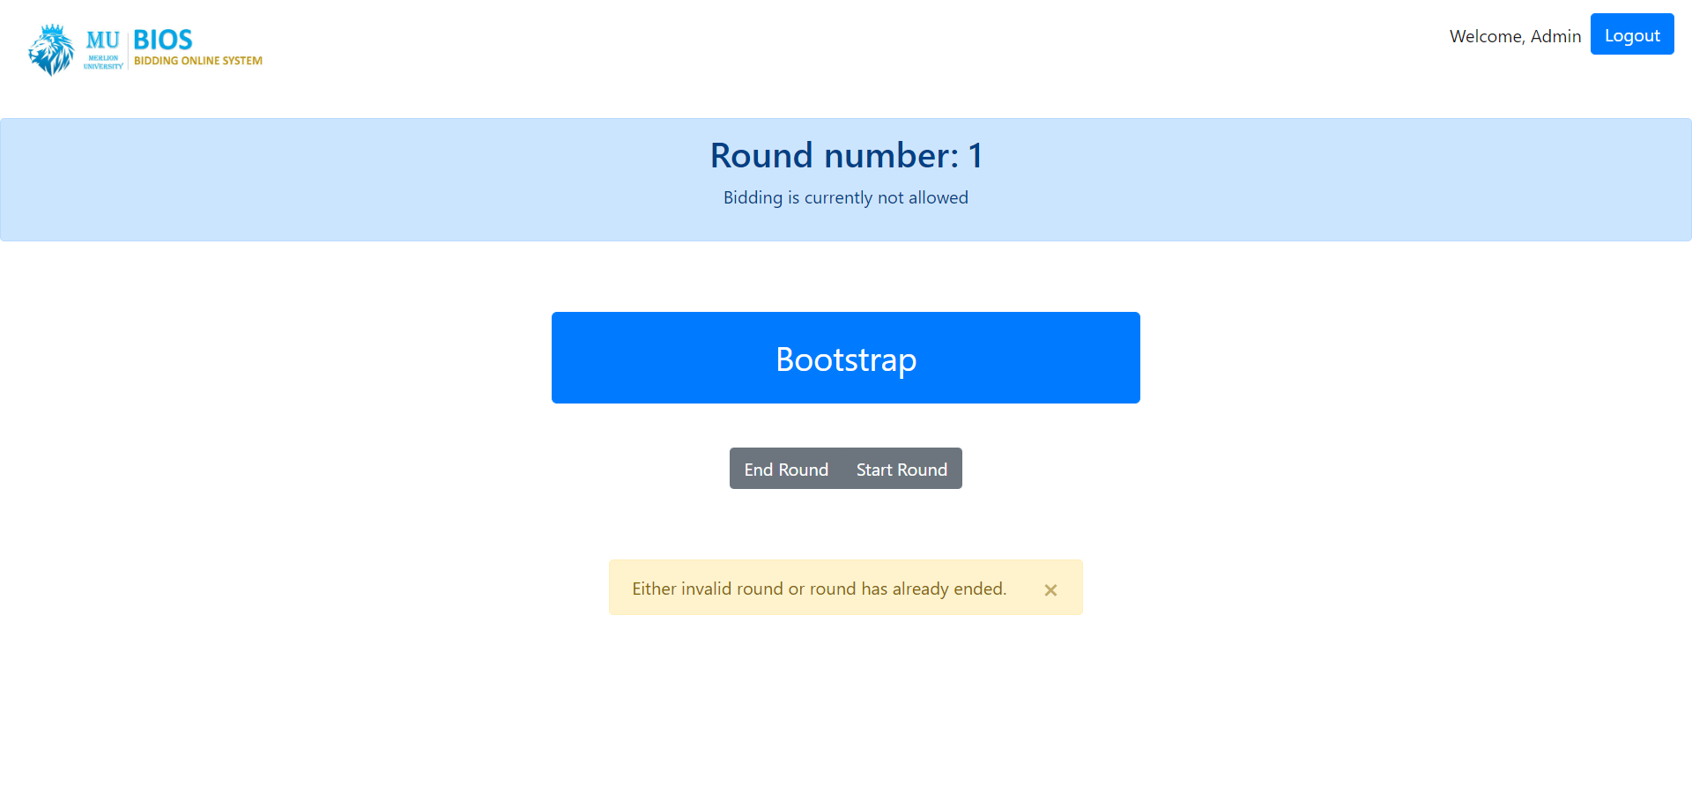

To resolve this problem, bootstrap a file first before ending a round, or start a round first. Ensure that the round is active first before attempting to end the round.

# Start Round

To start the next round after the current round ended, the admin has to click the start round button. A message indicating which round has started will be displayed. The admin can then confirm it by comparing it with the round number and bidding allowed found on top of the bootstrap button.

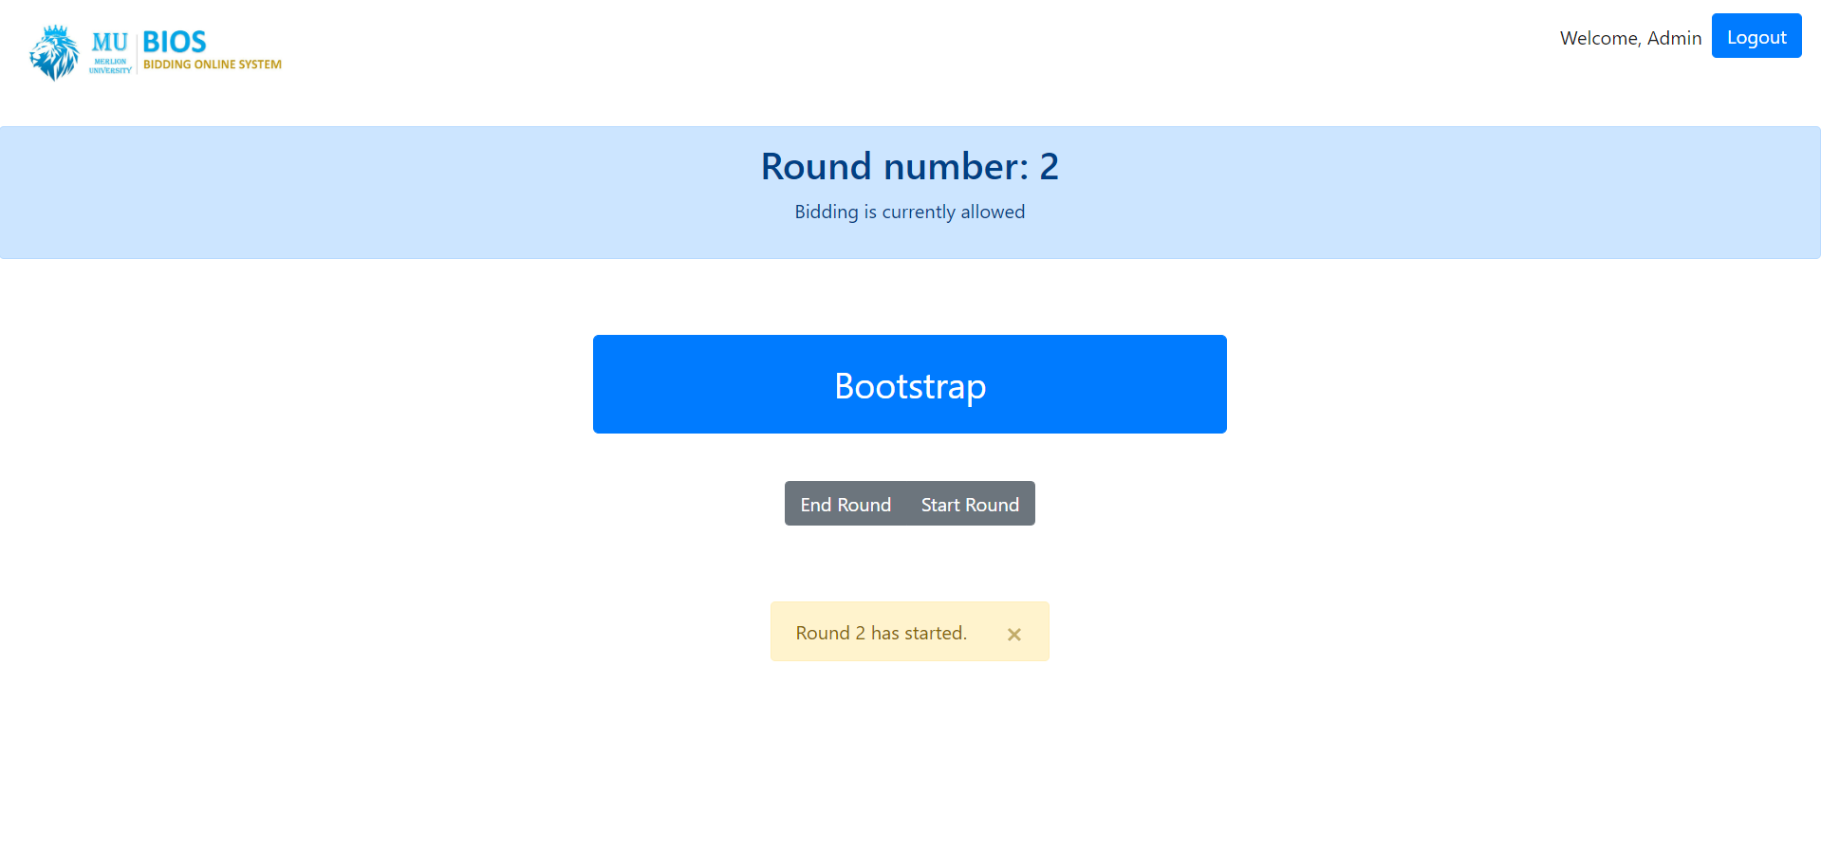

## Possible Errors

### Round already started/has not ended

If the admin tries to start a round while a round is still active, the system will display the following error message: “Cannot start round if: (1) it is not round 1 and (2) round 1 has not ended.”.

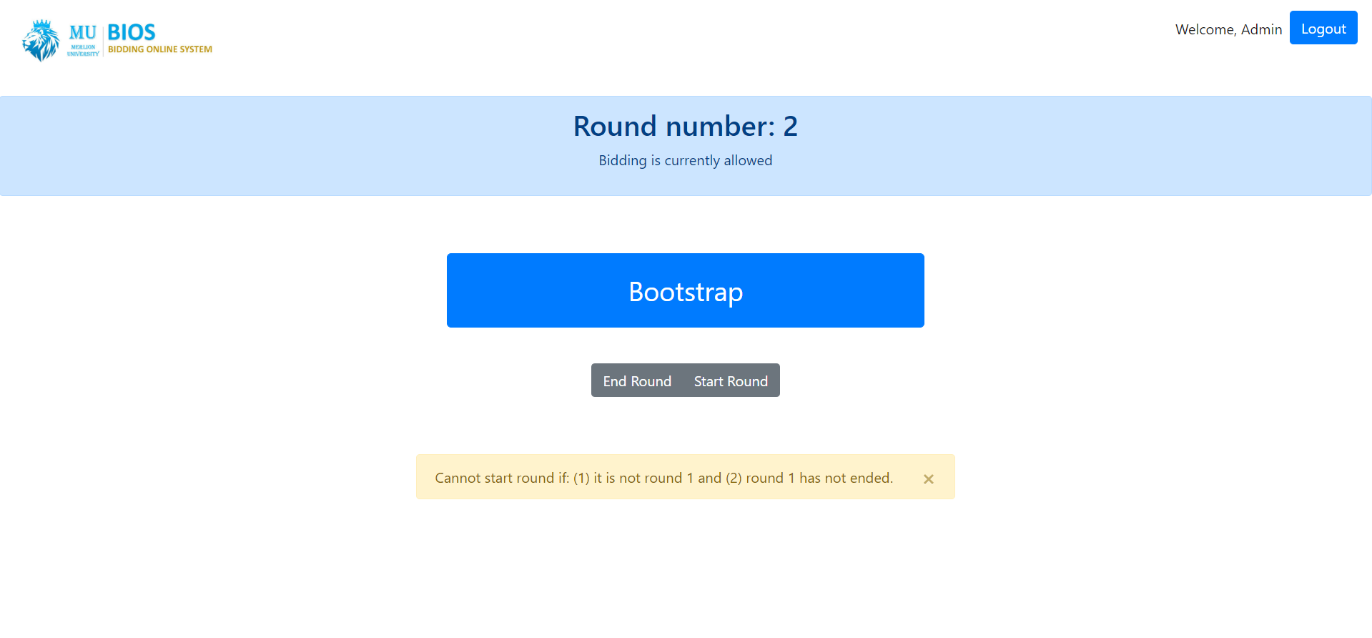

To resolve this problem, ensure that the current round number is 1 and that round 1 has ended before starting the round.

# Student Homepage

Once a student has successfully logged into the system, the student will be redirected to the student homepage:

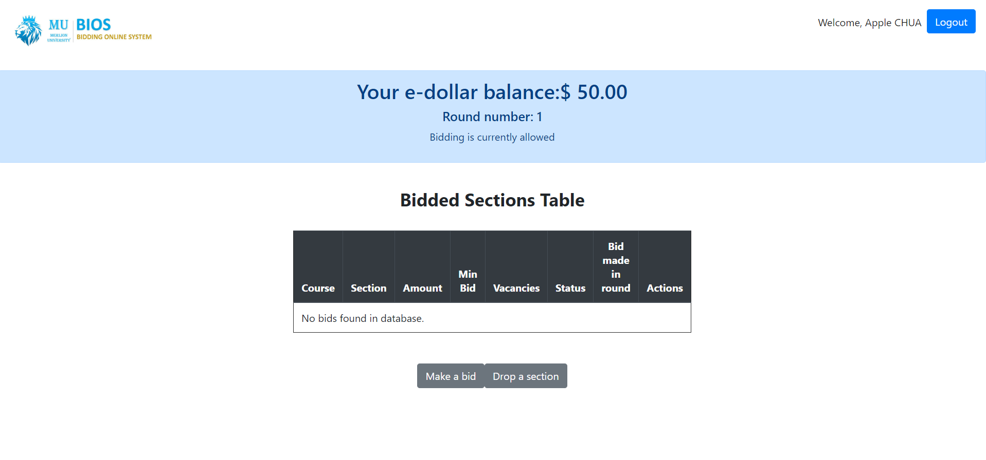

In the student homepage, the student can see the following:

1. The student’s name,
2. E-dollar balance,
3. Current round number and whether round is active/bidding is allowed.
4. A table showing the bids that the student has made with the following information:
   * Course
   * Section
   * Bid Amount
   * Min Bid
   * Vacancies
   * Status
   * Round which the bid was made in
   * Actions (e.g. delete bid) (if applicable).
5. Other actions which the student can do, such as making a bid or dropping a section the student enrolled.

# Adding Bids

If a student wants to add a bid, the student has to click the “Make a Bid” button at the student homepage. They will then be redirected to the following add bid page:

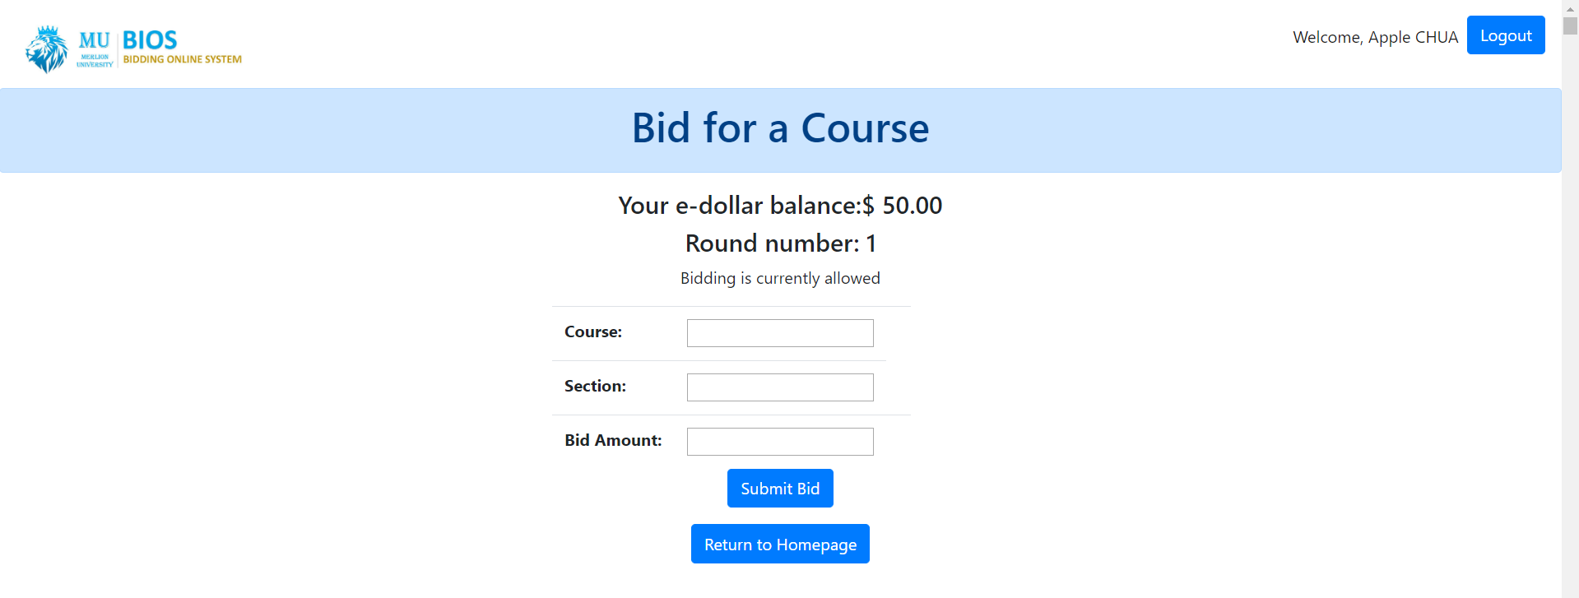

When the student scrolls down the page, they can see a list of courses and sections:

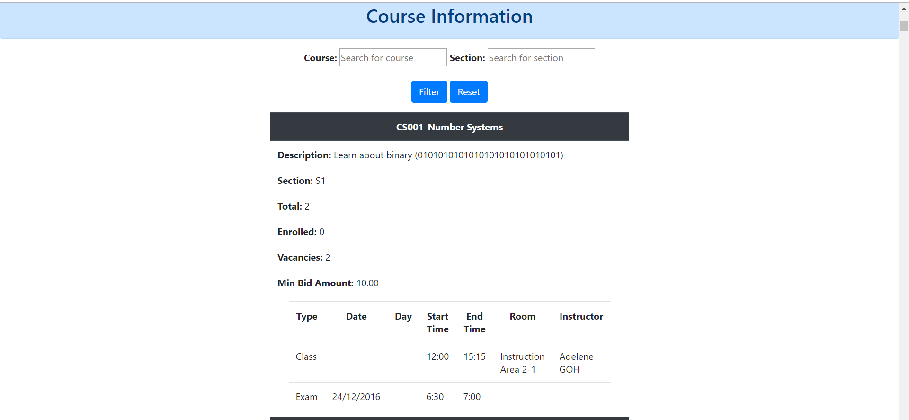

The course information will include the course code, course name, description, section, size, number of students enrolled, number of vacancies, minimum bid amount, and the class and exam time/room/instructor.

To add a bid, the student has to fill in the course, section and amount they want to bid and click the “Submit Bid” button.

Should a bid be added successfully, the following message is displayed: “Bid added successfully.”.

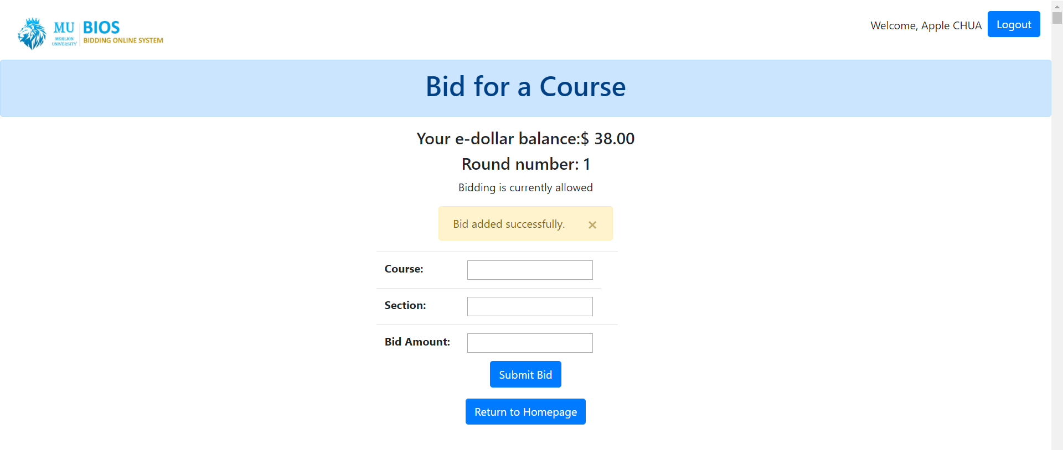

If the round has ended, the user will not be able to access this page from the student homepage. The button will not be seen.

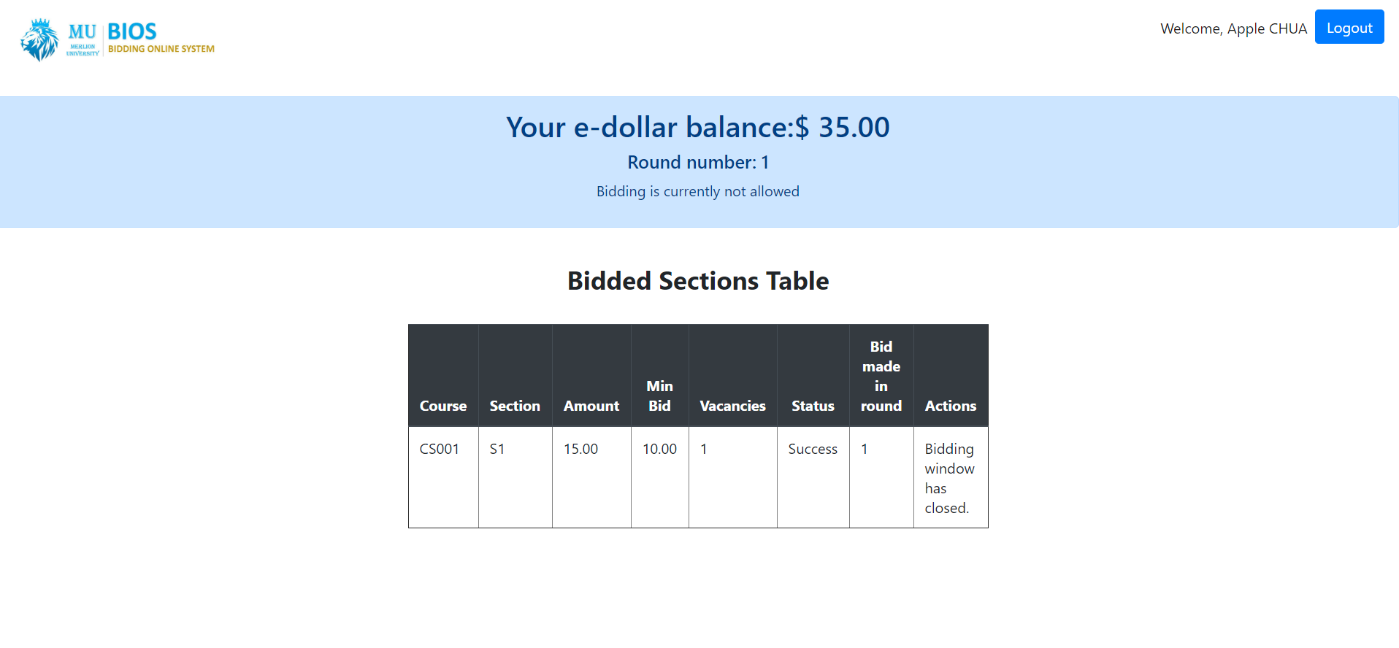

## Problems When Adding Bids

### Not All Form Fields are Filled

Should all fields in the add bid form are not filled, when the student attempts to add a bid, the following error message will be displayed: “Reason: Please fill up all fields”.

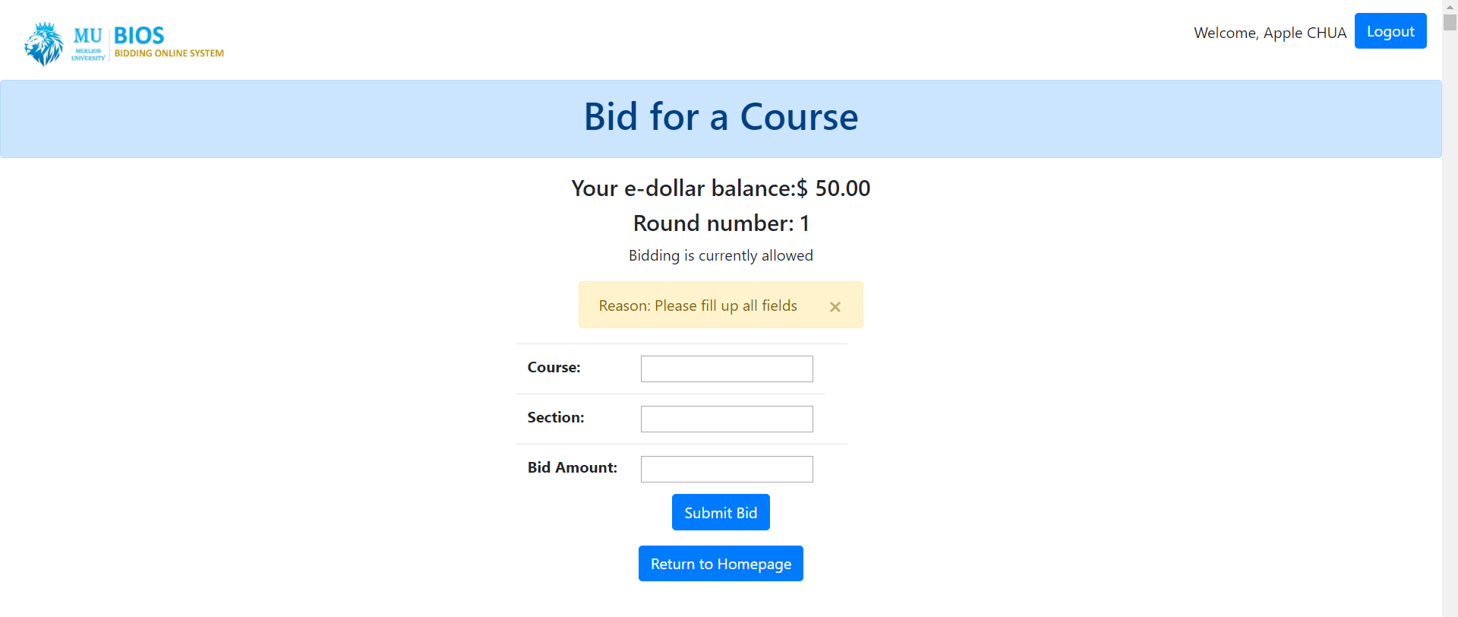

To resolve this problem, ensure that the student enters all form fields before clicking the submit bid button.

### Unsuccessful Adding of Bids

Should all form fields be entered, students may sometimes see that the adding of their bid was unsuccessful. This could be is due to the following:

1. Invalid course,
2. Invalid section,
3. Invalid bid amount,
4. Bid amount is below min bid price (default value of e$10.00),
5. Insufficient e$ balance to make a bid for that amount,
6. Class timetable clash with prior bids that are successful or still pending,
7. Exam timetable clash with prior bids that are successful or still pending,
8. Student is already enrolled in the course,
9. Student did not complete the prerequisites required for the course,
10. Bidding is not allowed,
11. Student has already completed the course,
12. Student has already reached section limit,
13. Student bids for a course which is not from the same school (will only occur when bid is made during round 1),
14. There are no more vacancies left for that section.

Should any of the above conditions are met, the corresponding error message will be displayed by the system. For example, if the course code is not found in the database, the following error message can be seen:

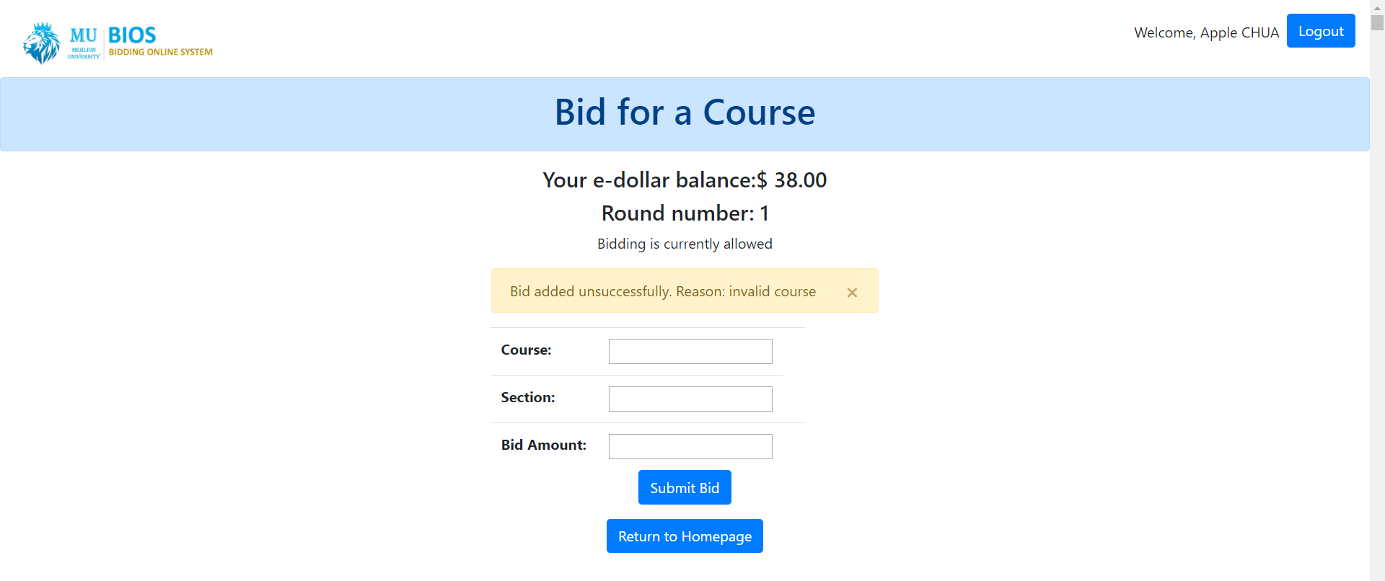

To resolve this problem, ensure that the above conditions are not met when adding a bid.

# Deleting Bids

Should a student have any bids, they will see a table with information regarding their bid, such as:

1. Course Code,
2. Section,
3. Amount,
4. Min Bid Price,
5. Vacancies,
6. Status,
7. Round number the bid was made in,
8. If the bid was made in round 1 and still pending, and the round is still active, they will have the ability to drop their bid, as shown in the picture on the following page:

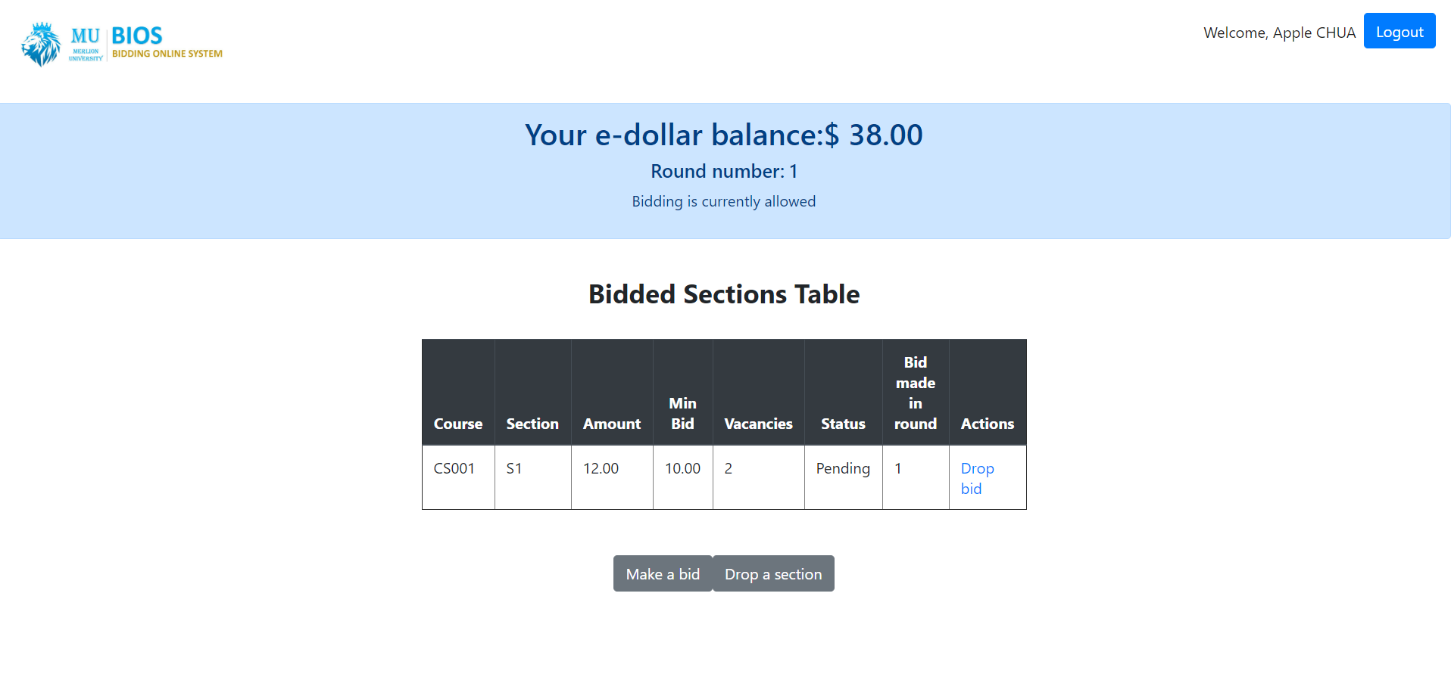

To drop a bid, click on the “Drop bid” link under the “Actions column”. If the bid is dropped successfully, there will be a corresponding message displayed by the system.

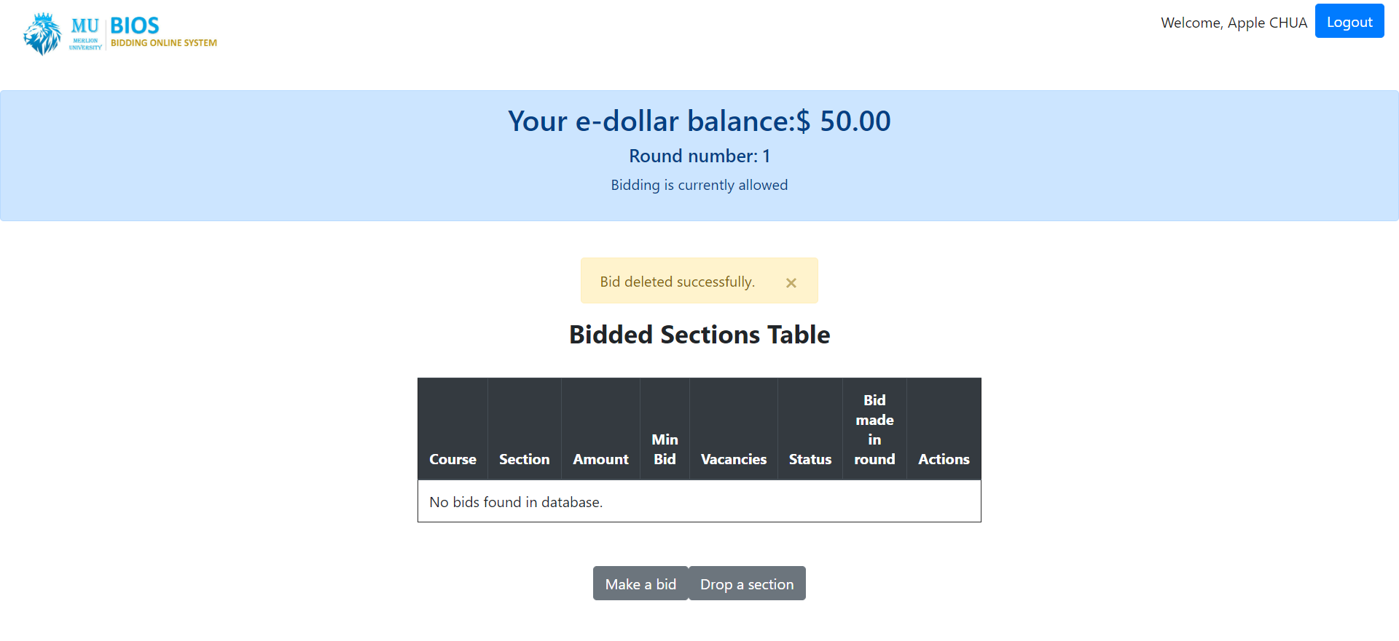

In round 1, if the bid is not pending, or the round is not active, the student will not be able to drop the bid. The clickable link will instead be replaced with an unclickable message indicating why the student is unable to drop the bid. For example, if Round 1 has ended, the student will see the message: “Bidding window has closed.” Instead of the link to “Drop bid”.



# Dropping Section

From the student homepage, a student if the round is active, the student is able to click on the button “Drop a section” to drop a section they have successfully enrolled in.



Once the student clicks on the “Drop a section” button, they will be brought to the following page:

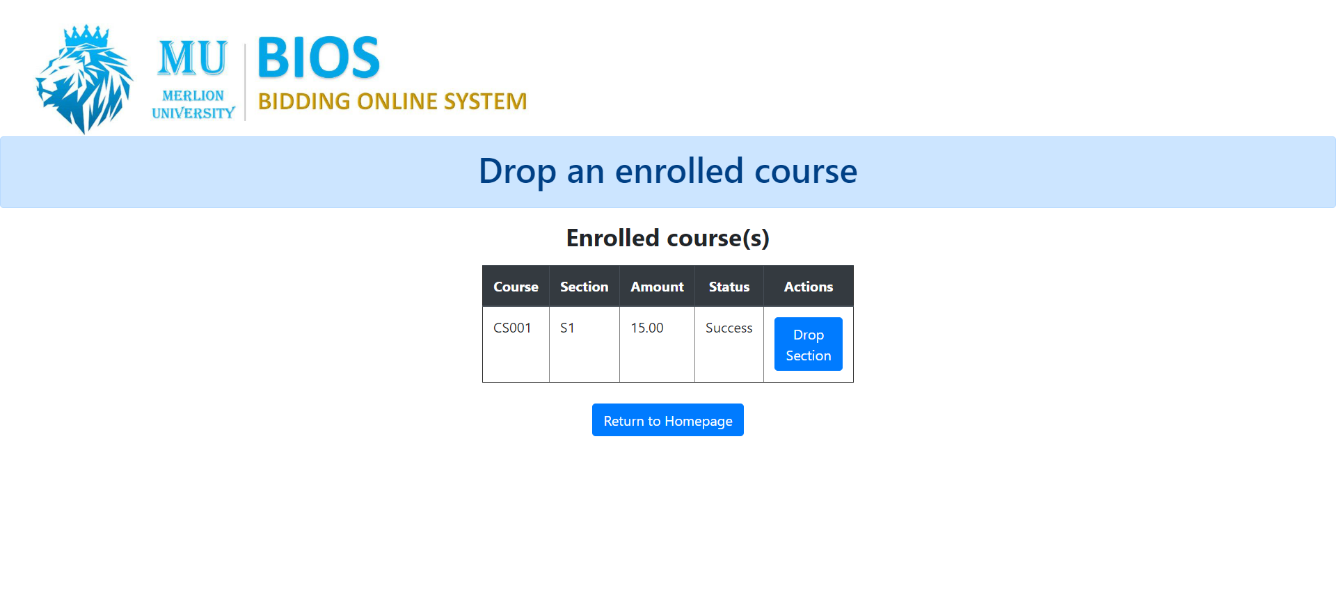

To drop a section, the student has to click the “Drop Section” Button for the corresponding section that they want to drop.

Once they have dropped the course, the following message is displayed: “Section dropped successfully.”.

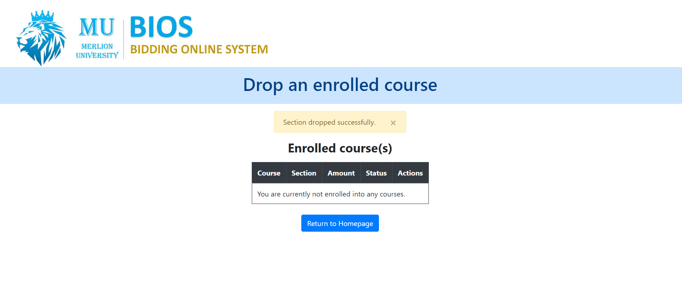

If the student is not enrolled in any course, they will see the following page:

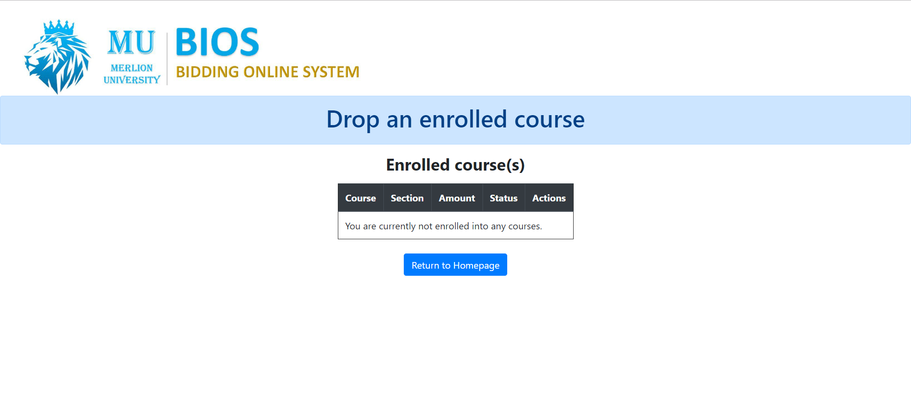

This means that while they can still access the page, they cannot drop any section.